Eacn of the underlined words contatns either a spelling or grammaticai error. Write the  
correct word in each of the boxes. (12 marks) Co

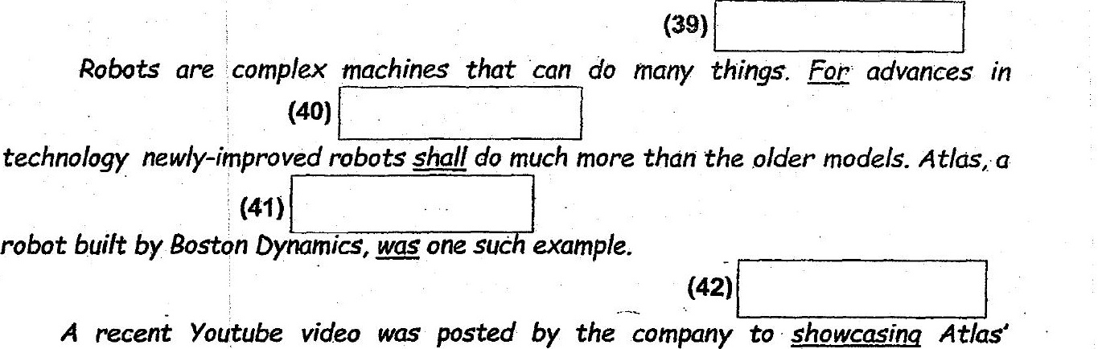

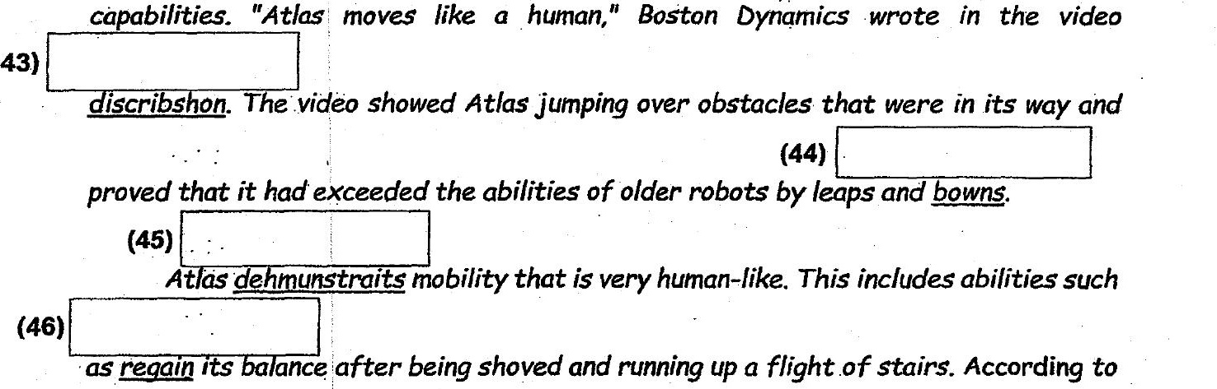

( eators, many sensors that are found in Atlas wo. A tg ether seamlessly to ensure -  
gnaseashun in Atlas’ physical movements, allowing it to mepaeyer skiliidly through

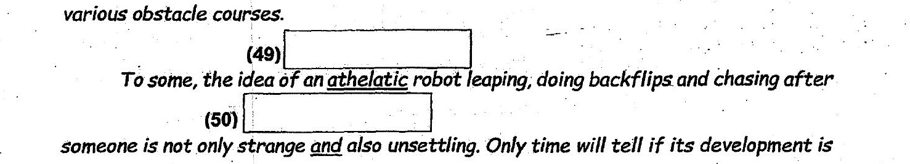

Marks

beneficial to humans.